|  |  |
| --- | --- |
|  | Project Report |
|  |  |
|  | ITRW 324  Group 17  10/3/19 |

**Thapelo Khanyile**: *27338053* **Nomonde Makgare**: *27378993* **Patrick Molusi**: *29317223* **Boitumelo Masilo**: *26496666*



**Table of Contents**

**Introduction** 1

**Project Proposal** 2

**Updated Scope** 2

**Proposed Solutions** 3

Client Technology 3

*Ionic* 3

*React Native* 3

*Android Studio* 4

Server and Web Technology 4

*API and Web Service* 4

*Firebase* 5

*Amazon Web Services* 5

Database Management System 6

**Relational Databases** 6

**NoSQL Databases** 7

**Team Management** 7

Collaborative Software 7

GitKraken 7

Trello 8

Bitrix24 8

Github 8

Slack 9

**Development Methodology** 9

DevOps 9

**DONE Retail Management System** 10

Designs 11

Technology 12

Android Studio 12

API/Web Server 12

Database 13

Division 13

Collaborative Software 13

• GitKraken 13

• Bitrix24 13

• Github 13

• Slack 13

Progress Report 14

Gantt Chart 14

Problems Encountered 14

Reflection 14

Final Thoughts (Per Person) 14

# **Introduction**

Done Retail Management System is a system created for retail groups dealing in supply chain, logistics and retail management that tracks a product from the warehouse to the store shelf until it is finally sold at any store. This document serves to provide progress and an update of the current state of the project, initial proposition and future projections and intentions. The initial project proposal and an updated version of the proposal are provided below.

You will find proposed and discussed solutions to achieve the systems completion as well as the final solution settled on. The team also provides a brief feedback on their individual progress on the project and its current standing.

# **Project Proposal**

“*The on-going project is for Shoprite/Checkers group. The Group constitutes of 3 Distribution centers, 3 Non-Perishable Distribution centers, 5000 suppliers and 2689 stores.*

*The systems that are currently in place to manage the supply chain are all internal. This makes for costly maintenance and possible data redundancy. This also means that staff can’t access the system outside of work. Therefore, inconveniencing top staff members from being able to manage the shop from a remote perspective.*

*The current point of sale system is that of a bulky cash register system, and the workers (shelving, storage and warehouse) use paper to pen registers for inventory and stock checks. This makes for an inaccurate system at times as the paper can go missing and workers are expected to get their part of the work done.*

*Something IT has taken it upon itself to get in contact with the manager of the store as well as the executive board and has constructed a proposal for a system to better workflow and efficiency in the workplace.*

*The system proposed is divided into 4 departments namely, Warehouse Management, Storeroom Management, Shelf Management and Point of Sale”*

# **Updated Scope**

# **Proposed Solutions**

## Client Technology

### *Ionic*

“Ionic is a cross-platform Mobile App Development, a complete open-source SDK for hybrid mobile app development using web technologies like HTML, CSS and JavaScript.”Patro(2019)

A hybrid mobile app according to Patro, “is built using technologies typically used for the web. Hybrid apps are hosted inside native applications that allow them to access the device’s camera, pedometer and other functionalities, removing the need to develop for any specific device or operating systems. This basically means that you are creating a website wrapped up inside an app.”

### *React Native*

“React Native is an open-source mobile application framework created by Facebook. React Native is a framework developed by Facebook for creating native-style apps for iOS & Android under one common language, JavaScript.” Patro(2019)

Unlike hybrid apps, Patro further elaborates that “native apps are built especially for the platform they’re to be used on (iOS,Android etc). React Native allows a proportion of the code to be shared between platforms and empowers developers to create apps which feel less clunky and perform better than hybrid apps.”

### *Android Studio*

Android Studio is an integrated development environment (IDE) from Google that provides developers with tools needed to build applications for the Android OS platform. The Android Studio IDE has a rich UI development environment with templates to give new developers a launching pad into Android development.

Android Studio is intended to be used by development teams as small as one person or as large as global teams. The Android Studio IDE can be linked to larger teams with GIT or similar version control services for larger teams. Mature Android developers will find tools that are necessary for large teams to deliver solutions rapidly to their customers. Android solutions can be developed using either Java or C++ in Android Studio.

## Server and Web Technology

### *API and Web Service*

The term “API” stands for Application Programming Interface. An API is an interface that can be used to program software that interacts with an existing application. Bush explains that “ In practice, an API is “a set of functions and procedures” that allow you to access and build upon the data and functionality of an existing application”. APIs have been described as the glue holding the Internet together.”

Rouse then defined a web service “as a software system designed to support interoperable machine-to-machine interaction over a network, a network-based resource that fulfils a specific task. It has an interface described in a machine- processable format (specifically WSDL). Other systems interact with the Web service in a manner prescribed by its description using SOAP-messages, typically conveyed using HTTP with an XML serialization in conjunction with other Web-related standards.

APIs and web services are not mutually exclusive. In fact, one is a subset of the other: every web service is an API — since it exposes an application’s data and/or functionality — but not every API is a web service. This is because the definition of a web service is quite restrictive when it comes to implementation: Web services require a network. While APIs can be on- or offline, web services must use a network.”

### *Firebase*

Firebase is an API that lets developers easily sync and store data in real-time. Bush further elaborates that “developers can use the service to build their apps without having to manage servers or write server-side code. There are clients for Android, iOS and JavaScript (including bindings for Ember, React, Angular and Backbone). The API allows users to access the functionality of Firebase programmatically. The API supports standard CRUD operations on the data within the databases as well as querying of the data. Firebase uses Web Sockets to archive real-time communication between clients. Data can also be accessed over the Firebase REST API.” “Firebase Simple Login is an additional service that allows developers to authenticate users using only client-side code. Enable authentication via a number of third-party providers, anonymous login, or email / password authentication without having to manually store authentication credentials or run a server.” Bush(2019)

### *Amazon Web Services*

Amazon API Gateway is an Amazon Web Services (AWS) service offering that allows a developer to connect non-AWS applications to AWS back-end resources, such as servers or code. Amazon API Gateway allows an AWS customer to increase the overall utility of Amazon’s other cloud services. The service manages traffic, authorizes end users and monitors performance. A developer can connect with services such as AWS Elastic Beanstalk and Elastic Compute Cloud (EC2) instances and event-driven code from AWS Lambda.

Amazon API Gateway provides security using access keys to control API access. The service interacts with Amazon Identity and Access Management and Amazon Cognito to authorize access to APIs. The service also supports AWS Signature Version 4 as an additional security option; this creates access keys for each API call. OAuth tokens can also be passed to running workloads as an alternative security measure.

## Database Management System

### **Relational Databases**

#### MariaDB

“MariaDB Server is one of the most popular database servers in the world. It’s made by the original developers of MySQL and guaranteed to stay open source. MariaDB turns data into structured information in a wide array of applications, ranging from banking to websites. It is an enhanced, drop-in replacement for MySQL.

MariaDB is used because it is fast, scalable and robust, with a rich ecosystem of storage engines, plugins and many other tools make it very versatile for a wide variety of use cases. MariaDB is developed as open source software and as a relational database it provides an SQL interface for accessing data. The latest versions of MariaDB also include GIS and JSON features.” Rouse(2016)

#### SQL Azure

According to Rouse SQL Azure is “Microsoft’s cloud database service. Based on SQL Server database technology and built on Microsoft’s Windows Azure cloud computing platform, SQL Azure enables organisations to store relational data in the cloud and quickly scale the size of their databases up or down as business needs change. Data is hosted, managed and provisioned in Microsoft data centres. Organizations can build applications on-premises and move them to SQL Azure or build them on Windows Azure and keep the data in the cloud.”

#### Oracle Database

### **NoSQL Databases**

#### Firebase Database

The Firebase Real-time Database is a cloud-hosted NoSQL database that lets you store and sync data between your users in realtime. Cloud Firestore, explains one of its designers that “it enables you to store, sync and query app data at global scale. Cloud Firestore is a fully-managed NoSQL document database for mobile and web app development. It's designed to easily store and sync app data at global scale. It allows for iOS, Android, and Web SDKs with offline data access, real-time data synchronization and Node, Python, Go, and Java server SDKs.”

#### DynamoDB

# **Team Management**

## Collaborative Software

Collaborative software or groupware is application software designed to help people involved in a common task to achieve their goals. Technopedia explains that, “In terms of the level of interaction it allows, collaborative software may be divided into: real-time collaborative editing platforms that allow multiple users to engage in live, simultaneous and reversible editing of a single file (usually a document), and version control platforms, which allow separate users to make parallel edits to a file, while preserving every saved edit by every user as multiple files (that are variants of the original file).”

## GitKraken

According to the GitKraken Organisation, “Axosoft GitKraken is a cross-platform Git client with efficiency, elegance and reliability at the core. It was made for devs by devs.” Osbourn further elaborated that, “t is a client for working with the version control system git. So it will handle merging, pushing, branching. It is cross platform, Efficient – It is quick to learn and performant, Elegant – It feels nice to use, it has a style to it and is reliable- It works consistently and does what you would expect to happen.”

## Trello

Trello as defined by its designers is a “collaboration tool that organizes your projects into boards. In one glance, Trello tells you what's being worked on, who's working on what, and where something is in a process.”

They further explained that it “organizes projects visually, in units called "boards." Boards contain lists of items, and each item is represented by a "card." There are many features which allow these components to be customized according to a project's needs.”

## Bitrix24

Bitrix24 is a collaboration software with complete tools for management, collaboration, and communication. “It gives you a unified platform for your files, projects, messages, tasks, and contacts. Through the Activity Stream, everyone in your team can keep track of tasks and effectively work together to progress on the project.

Its main solutions include social network, tasks and projects, CRM, document management, file sharing, calendar and planning, sales team management, email, telephone, and HR management. It also has a mobile solution that works on your smartphone or tablet whether it’s Android, iPhone, or iPad. The Bitrix app marketplace is available to create your own apps or use your existing systems.” Rouse(2016).

## Github

GitHub is a web-based version-control and collaboration platform for software developers. Rouse argues that “it is used to store the source code for a project and track the complete history of all changes to that code. It allows developers to collaborate on a project more effectively by providing tools for managing possibly conflicting changes from multiple developers.

GitHub facilitates social coding by providing a web interface to the Git code repository and management tools for collaboration. GitHub can be thought of as a serious social networking site for software developers. Members can follow each other, rate each other's work, receive updates for specific projects and communicate publicly or privately.”

## Slack

Slack software is cloud-based collaboration software suite. Rouse explains that “slack features include direct-messaging capabilities, notifications and alerts, document sharing, group chat and search. Slack offers integration with many third-party services, including Google Drive and Dropbox, and it is especially popular with software developers and technology-driven companies because it supports source code snippets and retains formatting for a variety of programming languages. Slack also offers integration options for developer-oriented tools such as GitHub”.

# **Development Methodology**

## DevOps

## Agile Development

# **DONE Retail Management System**

Plenty of time was spent trying to decide what works best for what we are trying to achieve for our app, and thus kept changing technologies until we settled on a more efficient approach. The current repo is DRMSv3.

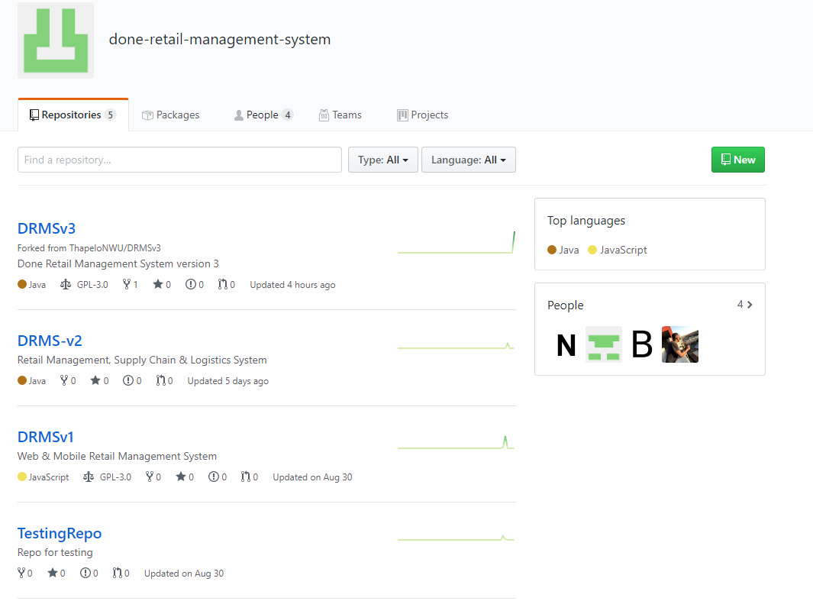

Figure 1: Done-retail-management-system Repo’s

|  |  |  |  |  |
| --- | --- | --- | --- | --- |
| **Scoring:** Exceeds | 3 |  | **Weighting:** Required | 300% |
| Meets requirements | 2 |  | Desired | 200% |
| Partially meets | 1 |  | Optional | 100% |
| Does not meet requirements | 0 |  |  |  |

# Decision Matrix

|  |  |  |  |  |  |  |  |  |  |  |
| --- | --- | --- | --- | --- | --- | --- | --- | --- | --- | --- |
|  |  |  |  |  |  |  | **Database Systems** | |  |  |
|  | **Section & Requirements** | **Level of** | **DynamoDB** | | **Oracle DB** | | **Maria DB** | | **Azure SQL** | |
|  | **Importance** |  |  |  |  |  |  |  |  |
|  |  | Score | Total | Score | Total | Score | Total | Score | Total |
|  |  |  |
|  | **Data Management** |  |  | **0** |  | **0** |  | **0** |  | **0** |
|  | Is the database in the cloud? | Desired |  | 400 |  | 0 |  | 0 |  | 400 |
|  |  | 2 | 0 | 0 | 2 |
|  |  |  |  |  |  |  |  |  |  |  |
|  | Can the database be integrated with our working environment? | Required |  | 300 |  | 600 |  | 600 |  | 900 |
|  |  | 1 | 2 | 2 | 3 |
|  |  |  |  |  |  |  |  |  |  |
|  | Are there active accounts with the respective services? | Required |  | 900 |  | 300 |  | 600 |  | 600 |
|  |  | 3 | 1 | 2 | 2 |
|  |  |  |  |  |  |  |  |  |  |
|  | Is the database secure enough? | Required |  | 900 |  | 600 |  | 600 |  | 900 |
|  |  | 3 | 2 | 2 | 3 |
|  |  |  |  |  |  |  |  |  |  |
|  | Is the team familiar with the database technology? | Required |  | 0 |  | 600 |  | 300 |  | 900 |
|  |  | 0 | 2 | 1 | 3 |
|  |  |  |  |  |  |  |  |  |  |
|  | TOTALS |  |  | 2500 |  | 2100 |  | 2100 |  | 3700 |
|  |  |  |  |  |  |  | **Development APIs, Frameworks & Environments** | |
|  | **Section & Requirements** | **Level of** | **Ionic** | | **React Native** | | **Android Native** | |
|  | **Importance** |  |  |  |  |  |  |
|  |  | Score | Total | Score | Total | Score | Total |
|  |  |  |
|  | **Development Targets** |  |  | **0** |  | **0** |  | **0** |
|  | Supports Cross-platform development | Desired |  | 400 |  | 400 |  | 0 |
|  |  | 2 | 2 | 0 |
|  |  |  |  |  |  |  |  |  |
|  | Supports native functions of device? | Required |  | 300 |  | 300 |  | 900 |
|  |  | 1 | 1 | 3 |
|  |  |  |  |  |  |  |  |
|  | Facilitates current infrastructure? | Required |  | 300 |  | 300 |  | 900 |
|  |  | 1 | 1 | 3 |
|  |  |  |  |  |  |  |  |
|  | Rapid development? | Optional |  | 200 |  | 200 |  | 100 |
|  |  | 2 | 2 | 1 |
|  |  |  |  |  |  |  |  |
|  | Is the team familiar with the database technology? | Required |  | 0 |  | 0 |  | 600 |
|  |  | 0 | 0 | 2 |
|  |  |  |  |  |  |  |  |
|  | TOTALS |  |  | 1200 |  | 1200 |  | 2500 |

The following decisions were made based on this matrix, amongst other factors that include:

1. Scalability
2. Steepness of learning curve
3. Available resources
4. Requirements of application
5. Effectiveness
6. Security

Therefore, the following technologies were selected:

1. Android Native Development in Java (API 28)
2. AWS Incognito
3. Azure SQL Database
4. AWS Gateway (using RESTful API)

The team agreed that DevOps would be the best manner to proceed developing our application. However our DevOps methodology implementation takes some ques from Scrum in the sense of sprints. Weekly sprints were incorporated into our development cycle as means of keeping track of progress and workflow.

# Designs

## Paper Prototype

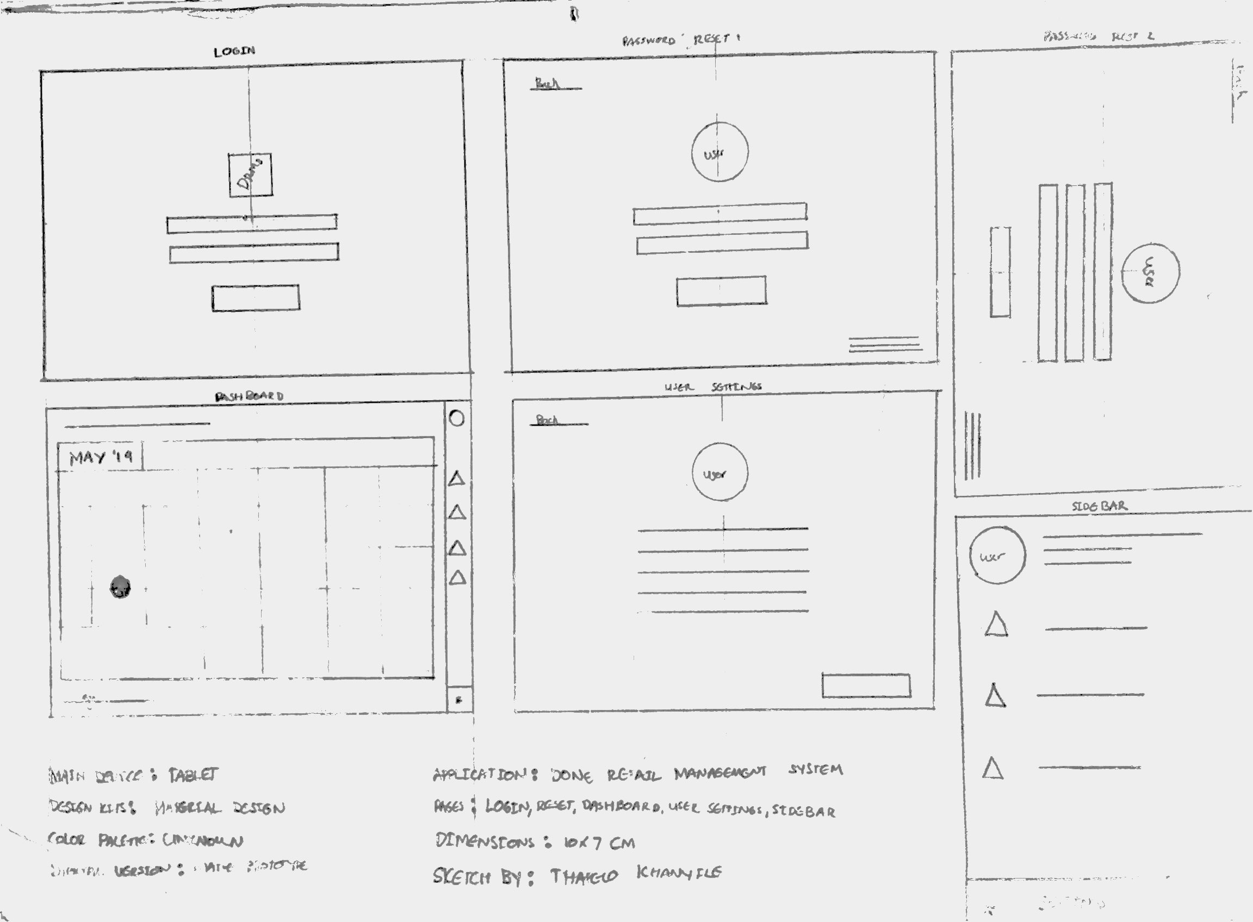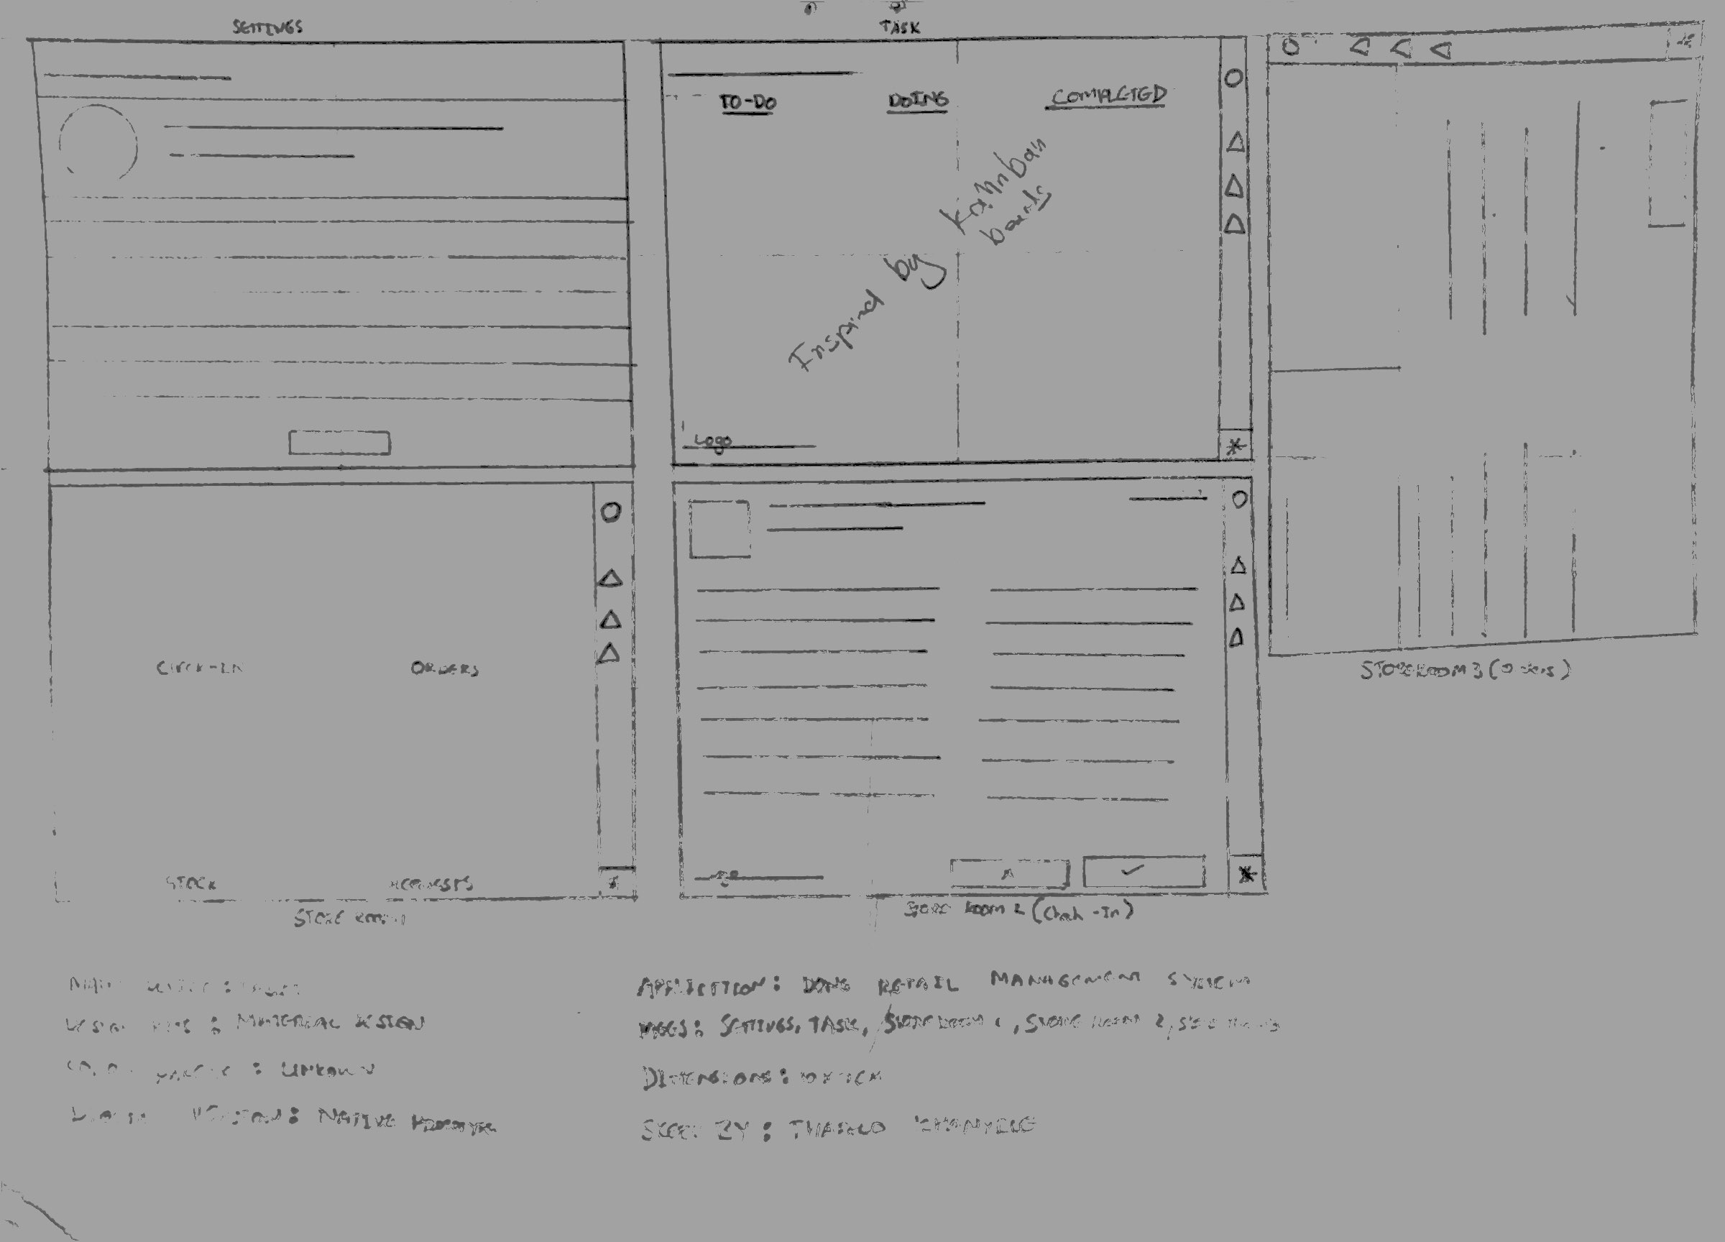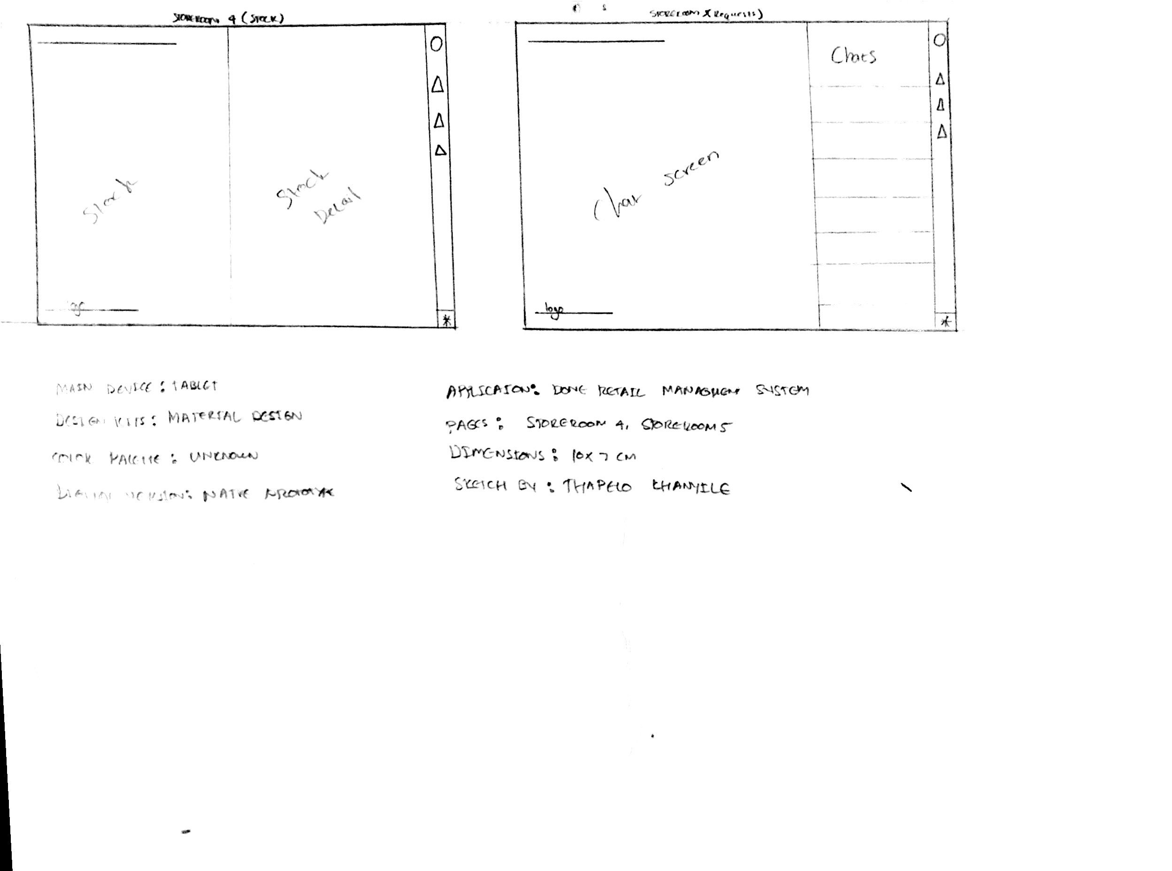

Paper prototyping was used during the design phase as a means of understanding the flow of the application and how different pages are going to affect and interact with one another. This process assisted highly and was a Launchpad for development phase as it was used as a reference point.

# Technology

Initially, according to our initial project proposal, we wanted to use Ionic, but later realized that we don’t want a hybrid application, an app that runs on a web browser, also its 2019, such apps are slowly becoming extinct.

We came across react native, which creates native applications and also uses new technology. But due to time restrictions and mainly because it is still fairly new it doesn’t not have a lot of internet support(help), which was the downside especially since we had to learn as we go. We were also short on resources as the iOS platform needed a to be developed on a Mac.

## Android Studio

We went back to the drawing board to look for a technology that will follow our initial methodologies(DevOps) and produces a native application, at this point we were running behind schedule and needed to make a realistic choice.

We ended up using Android studio. There is support for all platforms of Android starting with Android 1.6 and later. The workflow for Android Studio is built around the concept of continuous integration. Continuous Integration allows for teams to test their code each and every time a developer checks in their work. Issues can be captured and reported to the team immediately. The only downside from our initial proposal is that this technology only developed for Android OS.

## API/Web Server

We realized that Android Studio works better with the Amazon Web Services, so we decided to use its API Gateway. We used the software development kit (SDK) to integrate with software that calls the APIs, including custom SDKs for mobile app and Web app development. Rouse explains that “We can monitor API calls on a metrics dashboard in Amazon API Gateway and can retrieve error, access and debug logs.

Amazon API Gateway provides security using access keys to control API access. The service interacts with Amazon Identity and Access Management and Amazon Cognito to authorize access to APIs. The service also supports AWS Signature Version 4 as an additional security option; this creates access keys for each API call. OAuth tokens can also be passed to running workloads as an alternative security measure.

The service also allows an AWS user to operate multiple versions of an API simultaneously, allowing a developer to build and deploy new APIs while existing applications use previous versions of the API.”

## Database

We used Azure SQL for our database. We stored and populated our data straight from the cloud.

## Division

## Collaborative Software

We used all of the below mentioned Collaborative Software:

### GitKraken and Gitkraken Glo Boards

GitKraken is utilised as our Git Client where commits, branches and merging are facilitated. Glo Boards for automation purposes if a problem or bug arises from any of the branches.

### Bitrix24

Bitrix24 manages the development team and keeps track of everything admin related. From planning to creating tasks and assigning tasks, storing all documentation, checking task progress as well as tracking hours spent working on the project. Bitrix24 also served as one of our communication mediums.

### Github

Github is used to store all project source code, and to track the completion of the tasks as it clearly shows the insight on what has been happening on the repository.

### Slack

We used Slack mainly for communicating with our Demi Xagarey Meyer as well as feedback and updates from Mr Henry Foulds what is expected from us.

## Progress Report

### Gantt Chart

* Where we are with the Project

## Problems Encountered

* Front End
* Back End

## Reflection

### Final Thoughts (Per Person)